SIMATS ENGINEERING (SAVEETHA SCHOOL OF ENGINEERING)
Department of Computer Science and Engineering
ASSESSMENT TOOL 1 – CONCEPT MAP

Course Code: | ITA0305 | Course Title: | Mobile computing
CO Assessed: | CO1 | Assessment: | Assessment Tool 1 – Concept Map
Weightage: | 60 % of CIA | Total Marks: | 20 marks
CO1 Statement: | Analyse the mobile network components, mobile base station, mobile infrastructures and protocols in cellular systems.
Student Name: | Suganthan Kumaresan | Reg. No.: | 192424105
Section / Batch: | B. Tech AIDS | Date: | 12-10-26

Code of Conduct

I Suganthan Kumaresan (192424105) (Name / Reg. No) certify that this submission is my original work and that I have adhered to the guidelines specified for this assessment. I understand that any violation of academic integrity rules will result in disciplinary action.
Signature of the Student: K. Suganthan

Instructions
- This test contains ONE question.
- Duration: 30 minutes (At home)

Rubrics for Calculation

Criteria | Weightage | Level 4 – Exemplary | Level 3 – Proficient | Level 2 – Developing | Level 1 – Beginning
Understanding of Problem Context | 4 | Clearly understands the problem and accurately identifies all requirements | Good understanding with minor gaps | Basic understanding; some requirements unclear | Poor understanding or misinterpretation of the problem
Application of Concepts | 6 | Accurately applies appropriate concepts to solve complex problems | Applies relevant concepts correctly with minor errors | Applies basic concepts with limited accuracy | Fails to apply appropriate concepts
Problem-Solving Approach | 4 | Logical, well-structured, and efficient approach | Mostly logical approach with minor gaps | Basic approach with some inconsistencies | Illogical or unclear approach
Accuracy of Solution | 4 | Completely correct solution with proper justification | Mostly correct with minor errors | Partially correct solution | Incorrect or incomplete solution
Clarity | 2 | Clear, well-organized, and properly explained solution | Understandable with minor clarity issues | Limited clarity and explanation | Poorly presented and difficult to understand

Faculty In-charge | Course Coordinator | Program Director
Signature: _______________ | Signature: _______________ | Signature: _______________
Date: ___________________ | Date: ___________________ | Date: ___________________

Question

35. Develop a concept map that evaluates the routing of an incoming call to a roaming subscriber.
• Relate the Gateway MSC, HLR interrogation, the Mobile Station Roaming Number, the visited MSC and the VLR.
• Assess the efficiency of this routing and the problem of call tromboning.
• Justify your evaluation through interconnected concepts.
=
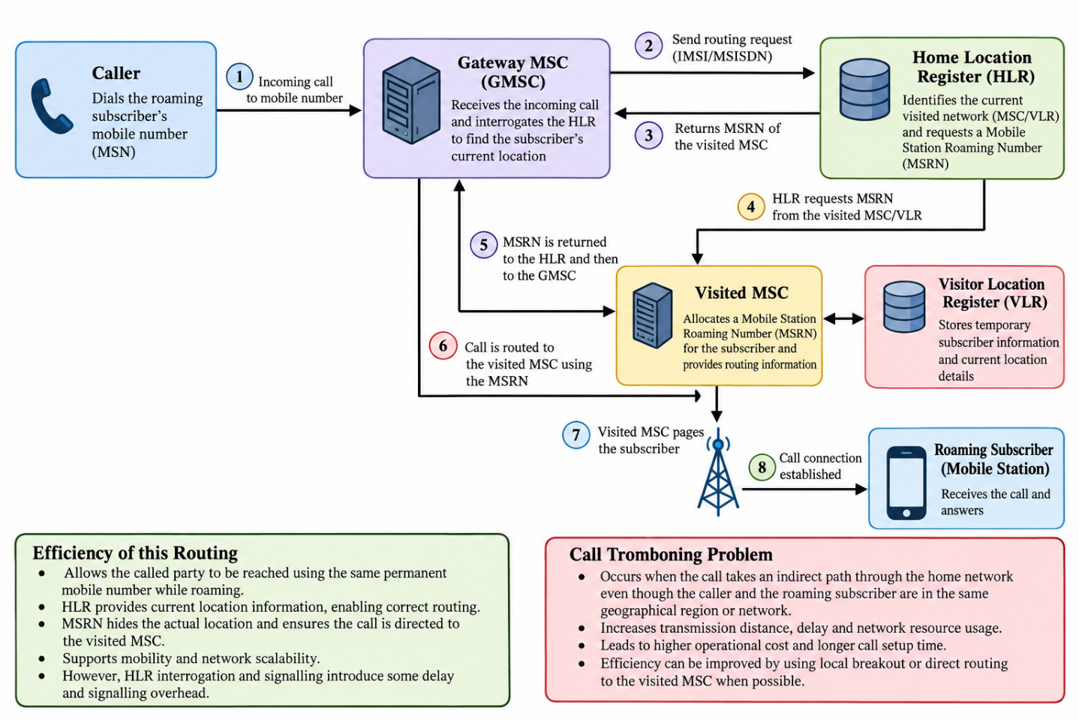

Explanation of the Concept Map

1. Introduction
Routing an incoming call to a roaming subscriber is an important function of a mobile communication network. When a subscriber moves outside their home network, the network must identify their current location and route incoming calls to the correct visited network.

2. Working Principle
When a caller dials the subscriber's mobile number, the Gateway Mobile Switching Centre (GMSC) receives the call and contacts the Home Location Register (HLR). The HLR identifies the subscriber's current serving network and requests a Mobile Station Roaming Number (MSRN) from the visited network. The visited MSC allocates the MSRN, with the VLR providing the necessary subscriber and location information. The MSRN is returned through the HLR to the GMSC, which uses it to route the call to the visited MSC. Finally, the visited MSC locates the mobile station and establishes the call.

3. Role of the Main Components
- Gateway MSC (GMSC): Receives incoming calls and forwards them to the correct visited network.
- Home Location Register (HLR): Maintains permanent subscriber information and identifies the current serving network.
- Mobile Station Roaming Number (MSRN): Provides temporary routing information to direct the call to the visited MSC.
- Visited MSC: Handles call delivery to the roaming subscriber.
- Visitor Location Register (VLR): Stores temporary subscriber details and location information in the visited network.

4. Evaluation of Routing Efficiency
This routing method allows subscribers to receive calls while travelling without changing their permanent mobile numbers. The HLR and MSRN help the network identify the correct destination. However, HLR interrogation and signalling exchanges can increase call setup time and consume network resources.

5. Call Tromboning Problem
Call tromboning occurs when a call follows an unnecessarily indirect route through the home network instead of taking a shorter available route. This can increase transmission distance, latency, and operational costs. Local breakout or more direct routing, where supported, can reduce unnecessary routing and improve efficiency.

6. Conclusion
The concept map illustrates how the GMSC, HLR, MSRN, visited MSC, and VLR work together to deliver calls to roaming subscribers. Although this method provides reliable subscriber reachability and mobility, efficient route selection is important to reduce signalling overhead, call delays, and call tromboning.

